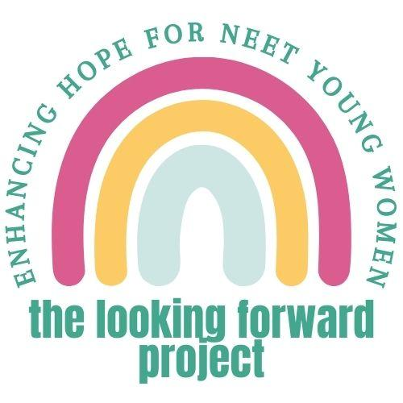
Participant Information Sheet for Mentors

We would like to invite you to take part in The Looking Forward Project. This is a research project. This information sheet will tell you why this project is being done and what will happen if you decide to take part. Please take as much time as you need to read and understand the information. It is up to you whether you take part or not. If there is anything you don’t understand you (or someone on your behalf) can contact a member of the research team. You will find our contact details at the end of this information sheet. You can watch a video version of this information sheet by scanning the QR code below or using this weblink:
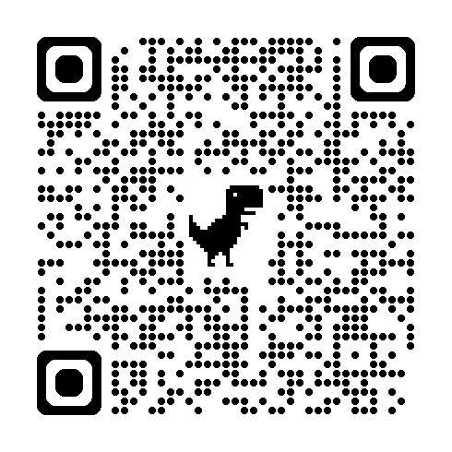

Why is the project being done?

We are testing a new way of helping young women who are not in education, employment, or training. We use the word “NEET” for short. We created this approach with NEET young women and the people that support them. It is called HOPEFUL. To learn if HOPEFUL is helpful, we need to conduct a kind of test that is called a randomised controlled trial. We use “trial” for short.

Why have I been invited to take part? And who can take part?

You have been invited to take part because a young woman involved in the project has said they would like you to mentor them to use the HOPEFUL intervention if you can. We encouraged them to select someone with whom they feel they have a supportive and positive relationship. Mentoring means using your natural skills in communicating and supporting people.

Your role would be to help the young woman to use the HOPEFUL package over a period of up to about 16 weeks. It is up to you and the young woman to decide how much time you will spend on this each week. Regular support does not need to take up a lot of your time. You would encourage the young woman to use the package and support them to do activities, like identifying their goals and breaking them down into manageable chunks. You would be given training and support to help you in your role as a mentor.

What does the project aim to do?

What does this project aim to do?  There are two stages to the project:  - Feasibility – in stage one, we will check that it is possible for us to run a trial of HOPEFUL, with mentor support  - Full trial – in stage two, we will evaluate whether (and how) HOPEFUL works  Assuming that stage one works well, we will start stage two. We will use the information we have gathered from young women in stage one. We will then involve more young women to do a more reliable test of HOPEFUL. If stage one did not work so well, we would make some changes to our research plans and then continue on to stage two.  This project will help us to learn:  - Whether we can run a trial of HOPEFUL  - Whether HOPEFUL improves hope  - Whether HOPEFUL improves mental health and activity  - Whether HOPEFUL makes cost savings for health and social services  - What the experience of HOPEFUL is like | What is HOPEFUL?  We know from our own and other research that NEET young women can often struggle with being hopeful. HOPEFUL is based on the idea that everyone’s hope can grow. Hope means belief in yourself and ability to work towards meaningful goals.  HOPEFUL aims to:  - improve hope  - improve mental health  - increase the time you spend in activities that are meaningful  HOPEFUL involves:  - video stories and activities that can be done in different ways, like writing, discussions, drawing, and collage  - working with a mentor – this is someone the young woman already knows, that they would like to support them to use HOPEFUL, like an aunt, sibling, family friend, or sports coach  How you and the young woman work together would be flexible and up to you both to decide together. If you don’t already know the young woman you would mentor, we would like to give the young woman an opportunity to meet you and agree to work with you before any mentoring starts.

Do I have to take part?

No. You can decide whether you want to act as a mentor or not. If you start mentoring and change your mind, you can withdraw at any time without giving a reason. It would be helpful for you to let the research team know if you are unable to continue mentoring so we can try to find the young woman a new mentor. Deciding not to take part (at any point) will not affect your medical or legal rights, or any support you may be receiving yourself from any services.

What will happen if I decide to take part?

You’ll meet with a researcher to go through this information sheet. Then you will sign a consent form if you would like to take part. You’ll answer a few short questions about you and your wellbeing. We expect this to take about 30 minutes. You’ll be given access to a manual and training materials and linked up with a youth worker from a local authority or charity who will offer you support and guidance in your role.

You and the young woman will decide together how your mentoring relationship will work. For example, you will decide together how often you’ll see each other and how you’ll meet. We will ask you to provide us with some information about these sorts of details, such as how many times you meet and what activities in the HOPEFUL package are completed. We will make giving us this information as quick and easy as possible. We will ask you to complete a survey about mentoring and two brief surveys about your wellbeing and experience of being a mentor. After 16 weeks, you may also be invited to take part in an individual interview to talk about your experiences of being a mentor in a bit more depth. This is optional. It would take up to about an hour and we would offer you a £20 shopping voucher for your time. We will aim to invite a diverse group of people to be interviewed, for example, of different ages.

Therefore, overall, you would be involved in the project for a little bit over 16 weeks in total. This allows for you to use the training materials before you provide mentoring for 16 weeks, then complete an assessment. You may also take part in a qualitative interview shortly after the 16-week assessment.

What are the possible risks and benefits of taking part?
We hope that providing mentoring to young women to use the HOPEFUL intervention will be a positive experience. Taking part could help the young woman you are mentoring. This project will also help us learn if the HOPEFUL intervention can help more young women in the future.
You might find it challenging to be a mentor. Your supervisor will be there to help and support you if so. It is possible that you could find it difficult to provide the records requested. The research team will support you to be able to do this in the way that feels easiest for you.
Will my involvement in the project be kept confidential?

The only people that will know you are taking part in this project will be the research team, the young woman you mentor, your mentoring supervisor and the organisation for whom they work, and anyone else that you choose to tell. Information collected about you in this project will be kept strictly confidential. We will only break this confidentiality where there are significant concerns about your safety or someone else’s safety. We will take all possible steps to discuss this with you first before contacting any relevant professional.

How will you use information about me?

We will need to use information from you for this research project. This information will include your name and contact details. People will use this information to do the research or to check your records to make sure that the research is being done properly. People who do not need to know who you are will not be able to see your name or contact details. Your data will have a code number instead. We will keep all information about you safe and secure. Information will be stored on password-protected secure NHS or university computer systems, or in locked filing cabinets in secure departments.

Once we have finished the study, we will keep some of the data so we can check the results. We will write our reports in a way that no-one can work out that you took part in the study.

If you take part in an audio-recorded interview, we will pay a professional transcription service to type up the audio-recording word-for-word. This is called a transcript. We will use a company that is registered with the University of Sussex for research interview transcription. We will ensure that any identifiable information (for example, names of people or places) mentioned in your recording is removed. We will then securely destroy the audio file and keep only the non-identifiable transcript.

Any personal information we have about you (your name and contact details) will be securely and confidentially destroyed two years after the study end date. We will securely destroy all research data (data that does not identify you personally) after 10 years after publishing the study report. However, a version of this research data will be kept on a data sharing site for use in further research projects. No-one would be able to work out who you are from saved research data.

What are my choices about how my information is used?

You can stop being part of the study at any time, without giving a reason, but we will keep information about you that we already have. We need to manage your records in specific ways for the research to be reliable. This means that we won’t be able to let you see or change the data we hold about you. At the end of the study, we will save some of the data (without your name or contact details) in case we need to check it and for future research. If you agree to take part in this study, you may take part in future research using your data saved from this study.

You can find out more about how we use your information by contacting a member of the research team or at www.hra.nhs.uk/information-about-patients/

What will happen to the results of the project?

We will use the results of this project to learn whether HOPEFUL is helpful for young women. We will write reports of the results from this project for participants, including a short video that we can send to you if you wish. We will also write reports for people who provide services for young people and for scientific journals and conferences. We will provide information about young women and mentors’ experiences using HOPEFUL on our project website. No-one will be able to tell that you took part in the project from the project website, or any of these reports or videos.

Who is organising and paying for the research?

The project is being run by a team of researchers from the Brighton and Sussex Medical School, King’s College London, University of Kent, Sussex Partnership NHS Foundation Trust, Norfolk & Suffolk NHS Foundation Trust, and University of Greenwich. The project is sponsored by the University of Sussex and is funded by the National Institute for Health and Care Research.

Who has approved the project?

Research projects like this can only go ahead if they have been approved by an NHS Research Ethics Committee. This committee checks that the risks of the research have been kept to a minimum and that we have given you all the information you need to decide whether to take part. This project has been approved by the London - Surrey NHS Research Ethics Committee (Reference IRAS 327723)..

What happens if something goes wrong?

The University of Sussex has insurance in place to cover its legal liabilities in respect of this study. If you are unhappy or have a concern about any aspect of this project, you can ask to speak to a member of the research team who will do their best to help.

If you would like to speak to someone outside of the research team for more information or if something goes wrong, you can speak to the sponsor, University of Sussex, by emailing researchsponsorship@sussex.ac.uk (or asking someone else to do this on your behalf).

Contact details:

If you would like to take part in this project or would like more information, you (or someone on your behalf) can get in touch with a member of the research time using the contact details below. They can typically be reached during office hours, Monday to Friday 9am to 5pm. Visit our website behopeful.ac.uk or email us: Safi S.Smith2@bsms.ac.uk (Sussex), Arti a.p.makwana-37@kent.ac.uk (Kent), or Zoe zoe.inman@nsft.nhs.uk (Norfolk).

