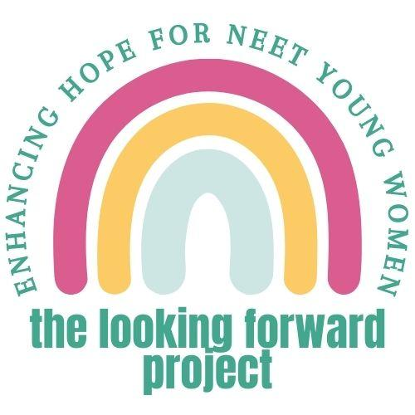
Easy Read Participant Information Sheet for Mentors

This information tells you about the project we are doing. You don’t have to take part in the project. It’s up to you. Please take your time to read this information. You can contact us if you don’t understand this information. You can also ask someone else to contact us for you. You will find our contact details at the end of this information sheet. You can watch a video version of this information sheet. Please scan the image below or use this weblink:
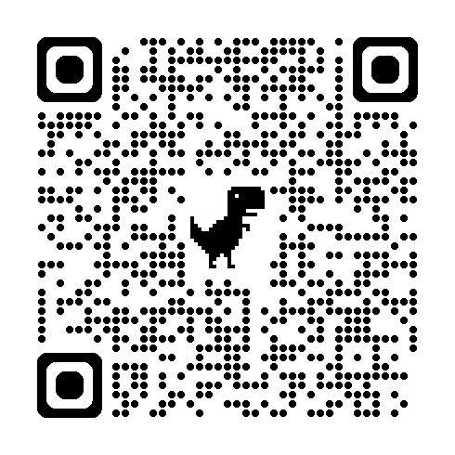
About this project
We want to help young women who are not in education, employment, or training. We call them “NEET” for short. We have created a new way to try and help them. We call it HOPEFUL. HOPEFUL is a workbook that young women use with the support of a mentor. We want to do a trial to test if HOPEFUL works well.

First, we want to test if young women and mentors want to take part in our trial. Then we want to test if HOPEFUL helps young women. We think it could help them to have more hope, and better mental health and wellbeing. But we won’t know this until we test HOPEFUL in this trial.

Why have I been invited to take part?

A young woman has said that they would like you to be their HOPEFUL mentor if you can. This young woman is already involved in the project. We encouraged them to identify someone with they trust and feel supported by.

More information about HOPEFUL
HOPEFUL is a workbook designed to try and help young women have more hope. It has video stories and different activities. The activities include things like working out what makes them feel hopeful and identifying their goals. The activities can be done in different ways. These include writing, talking, and drawing.

What is a mentor?
Mentoring means using your natural skills in communicating and supporting people. Your role would be to help the young woman to use the HOPEFUL workbook over about up to 16 weeks. It is up to you and the young woman to decide how much time you will spend on this each week. Regular support does not need to take up a lot of your time. You would encourage the young woman to use HOPEFUL. You would support them to understand and do activities. You would be given training and support to help you be a mentor.

Do I have to take part?
No. You can decide whether you want to act as a mentor or not. If you start mentoring and change your mind, you can stop without having to tell us why. Please do tell us that you have stopped though. This will help us to find the young woman another mentor. Saying no would not affect any care or support you were receiving outside of this project.

Who is in charge of the project?
The project is being done by researchers. These people work in a few different places including Brighton and Sussex Medical School. The University of Sussex sponsors the project. This means they are responsible for how it is run. An organisation called the National Institute for Health and Care Research is giving us the money to do the project.
Projects like this one also have to be looked at by an NHS Research Ethics Committee. This committee checks that the project is as safe as possible. This project has been approved by London - Surrey Research Ethics Committee (Reference IRAS 327723).

What happens in the project?
- Consent and questionnaire – if interested, you would sign a form to say you would like to be in the project and then we would ask you some brief questions about your own hope and wellbeing – this would take about 30 minutes
- Mentoring – you would support the young woman to use HOPEFUL up to about 16 weeks
  - We would make sure you have access to training and guidance materials
  - You would mentor the young woman in the way you agree to do together – this means you would decide how you work together, if and how often you see each other, for how long, and where
  - We would also link you with an experienced youth worker – this person would give you regular support and guidance to help you be a mentor, we would call them your supervisor
- Follow-up – you would meet with the researcher after 16 weeks, they would ask you some short questions about your hope, wellbeing, and experience of mentoring – this would take up to about 30 minutes
- Interview – you might be invited to take part in an interview, in which a researcher would ask about your thoughts and feelings about the project

Overall, you would be involved in the project for a maximum of a little bit over 16 weeks. This allows for some delays in you completing some training so you can start being a mentor and in arranging your meetings with the research team.

What are the possible risks and benefits of taking part?
We hope that being a mentor will be a positive experience. We hope that mentoring will also help the young woman. We can’t be sure though until we finish the project.
You could find it difficult to be a mentor. Your supervisor will be there to help and support you if so. You might find the project confusing. The research team will support you to understand the project.
Who would know you were in the project?
The people that would know you were taking part would be:
- Us, the research team
- The young woman you mentor
- Your mentor supervisor and the organisation they work for
How will your information be used?
In this research study, we will use information from you. We will only use information that we need for the research study. We will let very few people know your name or contact details, and only if they really need it for this study. Everyone involved in this study will keep your data safe and secure. We will also follow all privacy rules.

We will collect two types of information about you:
- Personal data – these are details about you, like your name and email address
- Research data – these are the answers you give to any surveys we ask you to do

We will store these two types of information separate to each other. If you take part in an interview about your experiences of the project, we will send the audio file to a professional transcribing service. They will type up everything that you and the person interviewing you say. We will then remove any identifying information, like names of people or places. We will then destroy the audio file.

At the end of the study, we will save some of the data in case we need to check it and for future research. We will make sure no-one can work out who you are from the reports we write or from the data we save. We will also make videos to show other people what we have found out in the project. We will make sure no-one can work out who you are from these videos.

What happens if something goes wrong?
The University of Sussex has insurance in place to cover its legal liabilities in respect of this this project. If you are unhappy or have a concern about any aspect of this project, you can speak to the research team who will do their best to help.

If you would like to speak to someone outside of the research team or if something goes wrong, you can speak to the sponsor, University of Sussex. You can email them at researchsponsorship@sussex.ac.uk or someone else could email them for you.

Contact details:
Please contact us if you would like to find out more. You can ask someone else to contact us if you like. We are usually at work Monday to Friday 9am to 5pm. Visit our website behopeful.ac.uk or email us: Safi S.Smith2@bsms.ac.uk (Sussex), Arti a.p.makwana-37@kent.ac.uk (Kent), or Zoe zoe.inman@nsft.nhs.uk (Norfolk).

