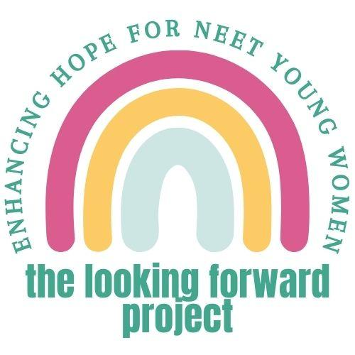

Easy Read Participant Information Sheet for Young Women

This information tells you about the project we are doing. You don’t have to take part in the project. It’s up to you. Please take your time to read this information. You can contact us if you don’t understand this information. You can also ask someone else to contact us for you. You will find our contact details at the end of this information sheet. You can watch a video version of this information sheet. You can scan the image below or use this weblink:
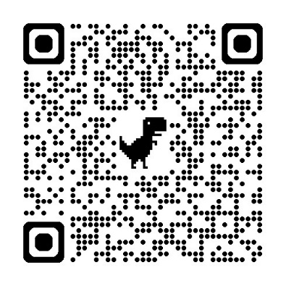
About this project
We want to help young women who are not in education, employment, or training. We call them “NEET” for short. We have created a new way to try and help them. We call it HOPEFUL. HOPEFUL is a workbook that young women use with the support of a mentor. We want to do a trial to test if HOPEFUL works well.

First, we want to test if young women and mentors want to take part in our trial. Then we want to test if HOPEFUL helps young women. We think it could help them to have more hope, and better mental health and wellbeing. But we won’t know this until we test HOPEFUL in this trial.

Who can take part?
You could take part if you are:
- currently not in education, employment, or training
- aged 16-25 years old
- identify as a young woman
- live in East Sussex, Brighton & Hove, Kent, Medway, or Norfolk.

If you are interested, we will ask you some questions to check if we think the project is right for you at this time.

Do you have to take part?
No. You can decide if you want to take part or not. If you start the project, you can still change your mind. You could leave at any time without having to tell us why. Saying no at any time would not affect any other care or support you get.

Who is in charge of the project?
The project is being done by researchers. These people work in a few different places including Brighton and Sussex Medical School. The University of Sussex sponsors the project. This means they are responsible for how it is run. An organisation called the National Institute for Health and Care Research is giving us the money to do the project.

Projects like this one also have to be looked at by an NHS Research Ethics Committee. This committee checks that the project is as safe as possible. This project has been approved by London - Surrey Research Ethics Committee (Reference IRAS 327723).

More information about HOPEFUL
HOPEFUL is a workbook designed to try and help young women have more hope. It has video stories and different activities. The activities can be done in different ways. These include writing, talking, and drawing.

A mentor helps each young woman to use the workbook. The mentor is someone you choose yourself. It should be someone you know and trust. It could be someone like an aunt or a football coach. You and your mentor would decide together how they would support you. If you can’t choose a mentor, or who you choose can’t take part, we will help you find a mentor. This would be someone working in youth support services. We would try to make sure you can meet this person before they start mentoring you.

What happens in the project?
- Consent – if interested, you would sign a form to say you would like to be in the project
- Eligibility assessment – we would ask you some questions to check the project seems right for you, this would take about 30 minutes
- Baseline assessment – on a different day, we would ask you some more questions about you and your mental health, this would take about 45 minutes and we would offer you a £20 shopping voucher
- Randomisation – a computer would put you in one of the two groups below, this would be done by chance like flipping a coin
  - HOPEFUL TOGETHER – you would start using the HOPEFUL workbook with the support of your mentor, you would also carry on with any other care or support you already get
  - HOPEFUL FUTURE - you would carry on with any other care or support you already had and after you finished the project, we would send you a HOPEFUL workbook to use however you want
- Follow-ups – we would ask you some more questions about you and your mental health at two more times - 16 weeks after you started the project and then 12 months after you started the project
  - Each time this would take about 40 minutes
  - We would give you a £20 shopping voucher each time
- Interview – you might be invited to take part in an interview for about an hour, in which a researcher would ask about your thoughts and feelings about the project

Overall, you would be involved in the project for a maximum of a little bit over 12 months. This allows for some delays in you being able to start working with your mentor (if you have one) and in arranging your meetings with the research team.

How would these meetings work?
You would meet with a researcher on a day and time suitable for you. You can meet with them either in-person, online or over the phone. If you meet online, this will be through video software (like Zoom or Microsoft Teams).

The researcher would help you to answer their questions. You can take a break any time. You can have a few short meetings each time if that works better for you.
What are the risks and benefits of the project?
We hope the project will be enjoyable for everyone who takes part. But it is possible that answering questions about yourself might be upsetting. We would ask you about things like mental health problems and thoughts about suicide. You could skip questions that you didn’t want to answer.

We hope that HOPEFUL will be helpful to those people who have it. But we don’t know for sure that it is helpful. We need to do this project to test if HOPEFUL is helpful.

Who would know you were in the project?
The people that would know you were taking part would be:
- Us, the research team
- Your GP (doctor)
- The support service that put you in touch with us, if there was one
- And your mentor and their supervisor, if you are in the HOPEFUL TOGETHER part of the project

We would tell your GP that you are involved and if you’re in HOPEFUL TOGETHER or HOPEFUL FUTURE. We would not tell them anything else about you unless we thought you were in danger. If we thought you were in danger, we would talk to you first. We would tell you what we wanted to tell your GP about. Then we would write them a letter to give them this information.

We would tell mentor supervisors your name. We would also tell mentor supervisors about whether you are aware of having an Education, Health and Care (EHC) plan, a mental health problem diagnosis, special educational needs, or have experience of care. This information will only be used to make sure we find the best supervisor for your mentor. Mentor supervisors will sign a data protection agreement to make sure that they do not share this information

How will your information be used?
In this research study, we will use information from you. We will only use information that we need for the research study. We will let very few people know your name or contact details, and only if they really need it for this study.

Everyone involved in this study will keep your data safe and secure. We will also follow all privacy rules.

We will collect two types of information about you:
- Personal data – these are details about you, like your name and email address
- Research data – these are the answers you give to surveys we ask you to do

We will store these two types of information separate to each other. If you take part in an interview about your experiences of the project, we will send the audio file to a professional transcribing service. They will type up everything that you say. We will then remove any identifying information, like names of people or places. We will then destroy the audio file.

At the end of the study, we will save some of the data in case we need to check it and for future research. We will make sure no-one can work out who you are from the reports we write or from the data we save. We will also make videos to to show other people what we have found out in the project. We will make sure no-one can work out who you are from these videos.

What happens if something goes wrong?
The University of Sussex has insurance in place to cover its legal liabilities in respect of this study. If you are unhappy or have a concern about any aspect of this project, you can speak to the research team who will do their best to help.

If you would like to speak to someone outside of the research team or if something goes wrong, you can speak to the sponsor, University of Sussex. You can email them at researchsponsorship@sussex.ac.uk or someone else could email them for you.

Contact details:
Please contact us if you would like to find out more. You can ask someone else to contact us if you like. We are usually at work Monday to Friday 9am to 5pm. Visit our website behopeful.ac.uk or email us: Safi S.Smith2@bsms.ac.uk (Sussex), Arti a.p.makwana-37@kent.ac.uk (Kent), or Zoe zoe.inman@nsft.nhs.uk (Norfolk).

